Welcome to Year Two, there are two classes:

Nightingale Class

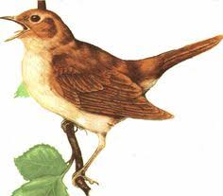

and Robin Class

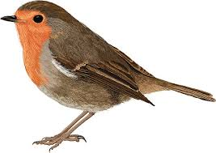

The teacher in Nightingale Class is Miss Bowie.

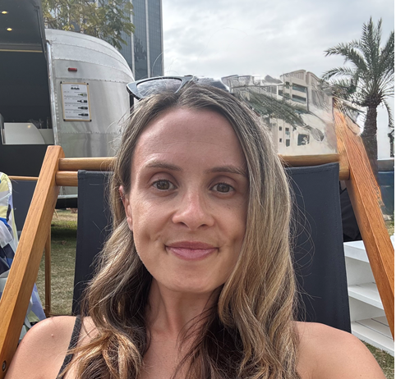

The teacher in Robin Class is Miss High.

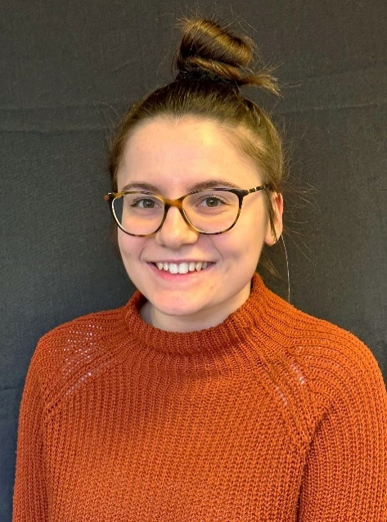

The LSAs in Year 2 are:

Mrs Purton

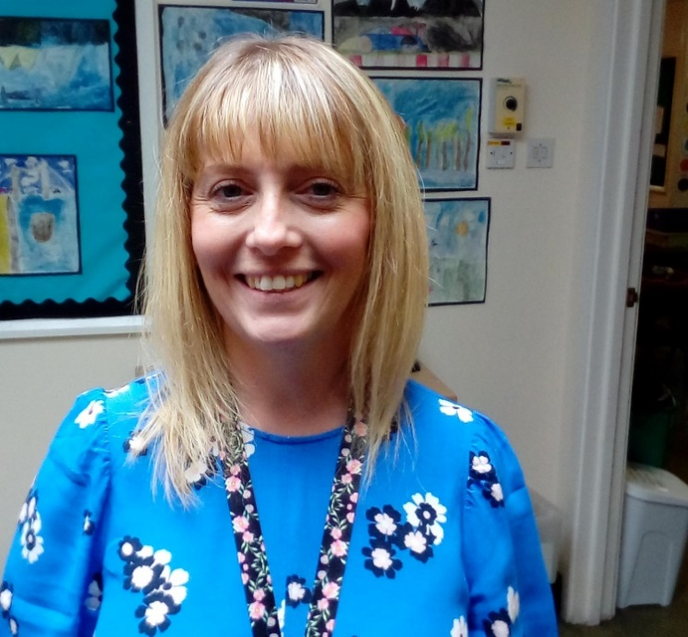

Mrs Tyler

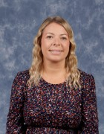

Mrs Green LSA/1:1



This is Nightingale Class.

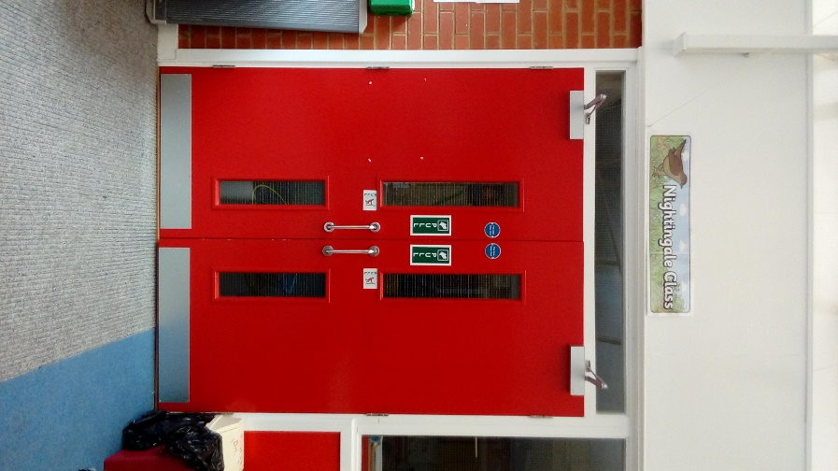

This is Robin Class.

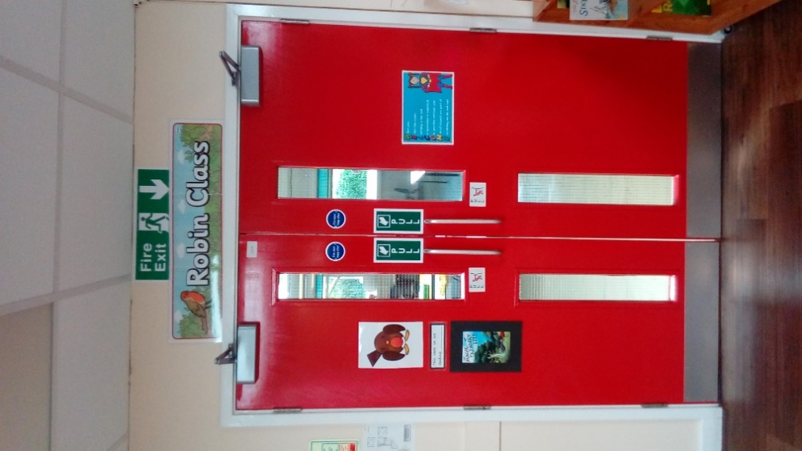

This where I will enter the school from the KS1 Playground.

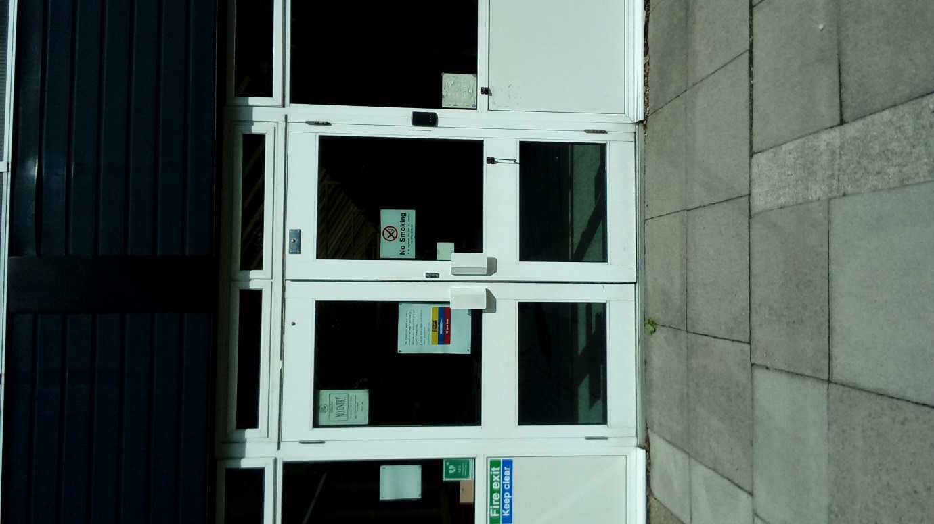

This is the route to Nightingale Class.

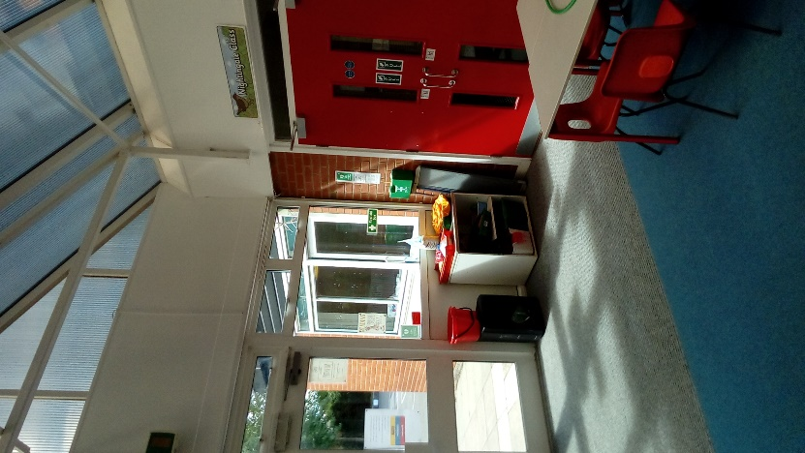

This is the route to Robin Class.

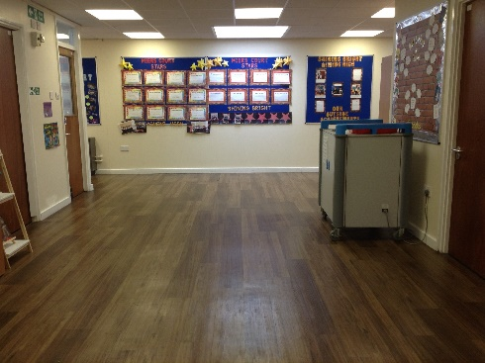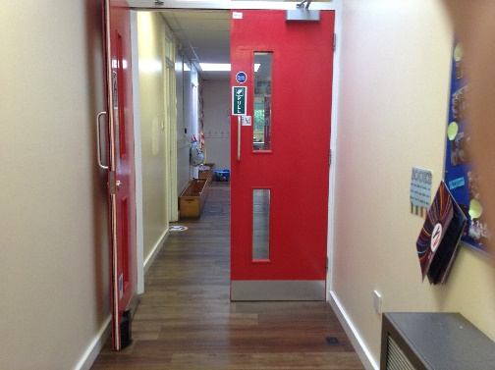

These are the toilets that I will use when I am in class.

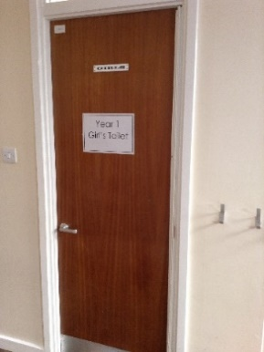 Girls Boys

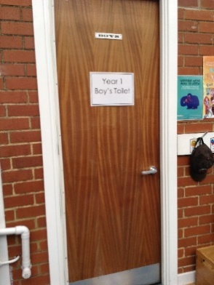

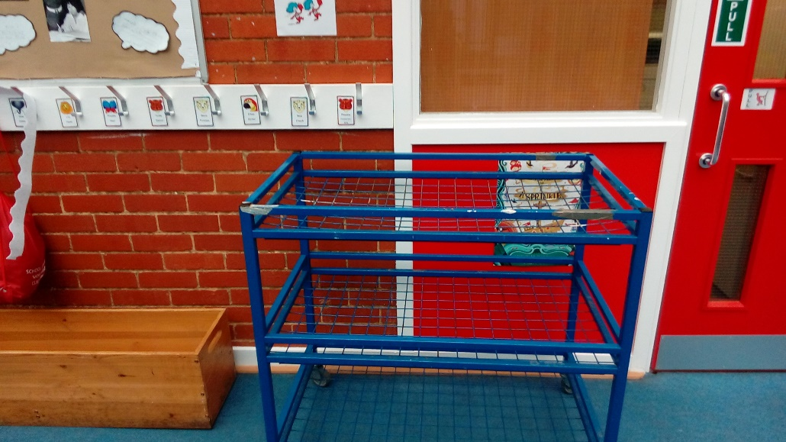This is where I will put my lunchbox.

This is where I will put my coat and bag for Nightingale Class.

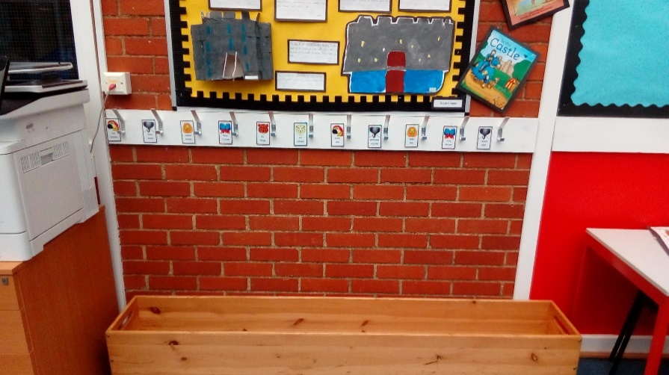

This is where I will put my coat and bag for Robin Class.

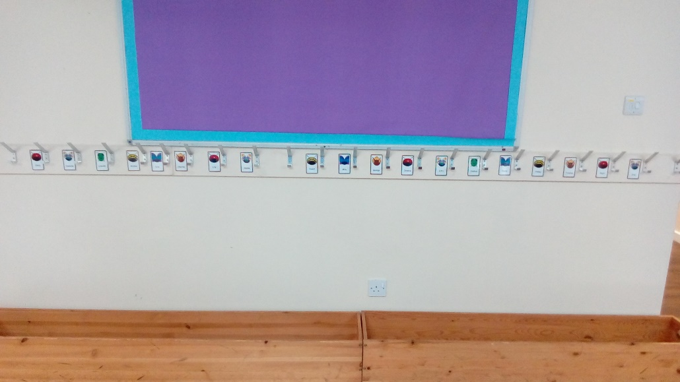

This is where I will work if I am not working in Nightingale or Robin Class.

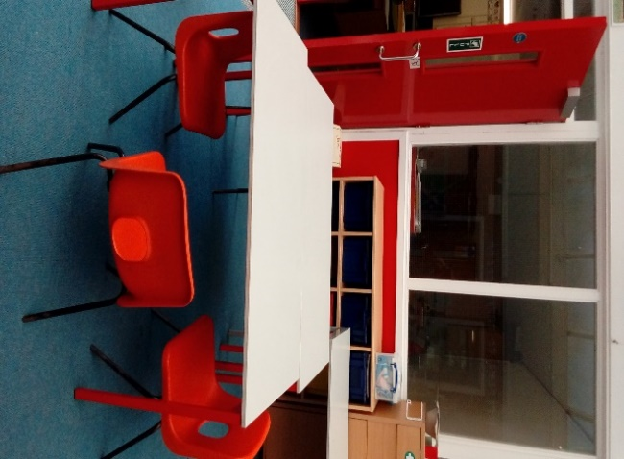

This is the playground where I will have my playtimes and lunchtime play.

